China Alumni Mini-App User Guide and Instruction
中国校友小程序使用指南
Updated on June 2026
Contents

1. About the alumni mini-app 1
2. What can you do on the mini-app 2
3. How to find the mini-app 3
4. How to complete alumni verification 4
5. How to organise your own alumni event 6
6. How to post job opportunities 8
7. Contact us 9

- About the alumni mini-app
关于校友小程序
We are happy to share that Phase 2 of the University of Bristol’s official WeChat alumni mini-app is now live. This is also the first WeChat mini-app created for Chinese alumni of a UK university.
我们很高兴跟大家分享，布里斯托大学官方校友小程序已已完成第二阶段升级，并正式上线。这也是首个英国大学专门为中国校友打造的微信小程序。

We are continuously improving the mini-app based on feedback from our alumni community, and we hope it will provide an even better experience for Bristol alumni in China.
我们将持续听取校友们的反馈，不断完善小程序功能和使用体验，希望为在中国的布大校友带来更好的使用体验。

This mini-app will help you stay connected with the University of Bristol and with other Bristol alumni across China. It provides a WeChat-based platform where alumni can access university updates, join alumni activities, explore local alumni networks, and discover career-related opportunities.
这个小程序将帮助你与布里斯托大学保持联系，也能帮助大家在中国各地与更多布大校友建立连接。通过这一平台，校友可以了解大学最新动态、参与校友活动、寻找本地校友组织，并探索职业发展相关机会。

In the future, both official alumni events organised by the University and activities initiated by alumni themselves will be published on the mini-app.
未来，大学校友部门组织的官方活动，以及校友们自行发起的各类活动，都将会在小程序中发布。

Join us on the mini-app to explore events and updates. We hope to see you there!
欢迎在小程序查看活动与最新动态。期待在小程序见到大家！

- What can you do on the mini-app
小程序可以做什么
Through the Alumni Mini-App, you can:
通过校友小程序，你可以：
- Explore and organise alumni events发现并发起校友活动
Discover and register for official University alumni events and alumni-organised activities. You can also submit your own alumni event ideas or activities to be shared on the mini-app.
查看并报名参加大学官方校友活动，以及校友自行组织的各类活动。你也可以提交自己想组织的校友活动或聚会，并通过小程序与更多校友分享。
- Connect with alumni networks 寻找校友组织
Find local and industry-based alumni communities across China.
发现中国各地及不同行业方向的校友社群，加入与你相关的校友网络。
- Access alumni news and updates 查看校友新闻与大学动态
Stay informed about University news, alumni stories and community updates.
获取大学最新资讯、校友故事和校友社群动态。
- Explore and share career opportunities探索并分享职业发展机会
Browse job opportunities and career-related information shared through the mini-app. You can also post suitable job opportunities or career-related information to share with the alumni community.
查看通过小程序发布的招聘信息及职业发展相关内容。你也可以自行发布合适的招聘信息或职业发展相关内容，与校友社群分享。
- Find and connect with other alumni发现并连接其他校友
Discover Bristol alumni across China and build meaningful connections based on shared locations, industries, interests or study backgrounds. You can choose whether to display selected parts of your alumni profile to help others connect with you more easily.
你可以通过小程序找到中国各地的布大校友，并根据所在城市、行业、兴趣或学习背景建立更有意义的联系。你也可以自行选择是否展示部分校友资料，帮助其他校友更方便地与你建立联系。

- How to find the mini-app
如何找到校友小程序
Please search ‘Bristol Alumni’ in WeChat, or simply scan the QR code below:
请在微信搜索“布里斯托大学Alumni”小程序，或者，直接用微信扫描下方小程序二维码。
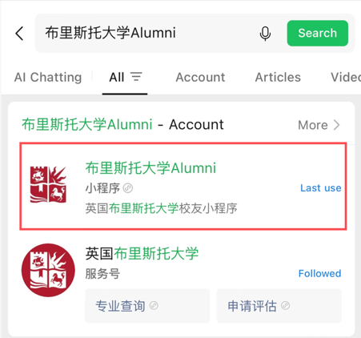

- How to complete alumni verification
如何完成小程序校友认证
All registered users can browse the mini-app. However, only verified alumni will have full access to all features, including registering for alumni events, receiving notifications, and using other alumni-only functions such as starting your own alumni events and posting job opportunities.
所有用户均可浏览小程序。但只有完成校友认证后，方可使用全部功能，包括报名参加校友活动、接收活动通知，以及使用其他校友专属功能比如发起你组织的校友活动和发布工作机会。
Step 1: Fill in your personal information
第一步：填写个人信息
In the mini-app, go to “My” – “Alumni Verification” and fill in the verification form. You will be asked to provide some basic personal and study information, such as your name, degree programme, student number, graduation year and contact details.
进入小程序后，点击 “我的” – “校友认证”，填写认证表单。你需要提供一些基本个人信息及学习经历信息，例如姓名、学位课程、学号、毕业年份及联系方式等。
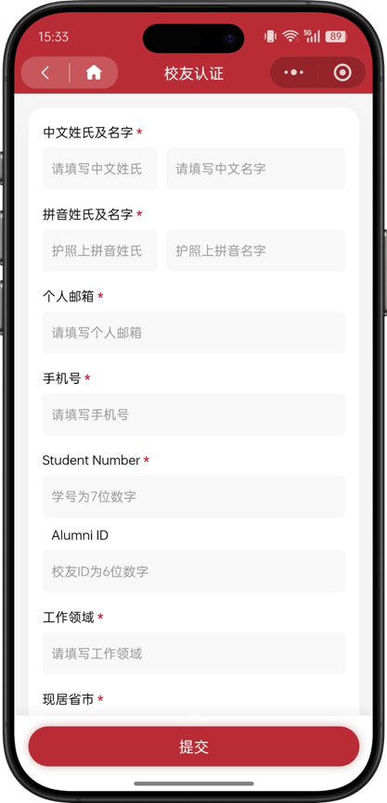
The University of Bristol will hold the data you provide, including contact details previously provided to the University, securely on the University’s alumni database. It will be treated confidentially in accordance with the UK Data Protection Act. You can read more about our data policy at: www.bristol.ac.uk/alumni-your-data
布里斯托大学将把你所提供的信息，包括此前向大学提供过的联系方式，安全保存在大学校友数据库中。相关信息将按照英国《数据保护法》进行保密处理。你可以通过以下链接了解更多数据政策：www.bristol.ac.uk/alumni-your-data
Step 2: Submit the form
第二步：提交表单
After completing the required information, please submit the verification form in the mini-app.
完成所需信息填写后，请在小程序中提交认证表单。
Step 3: Wait for verification
第三步：等待审核
Our team will review your submission as soon as possible. Once your alumni status has been successfully verified, your verification status will show as “Verified”, and you will be able to access all functions of the mini-app.
我们将在收到你的申请后尽快审核。审核完成后，校友认证状态将显示为 “已认证”，之后你即可正常使用小程序的全部功能。
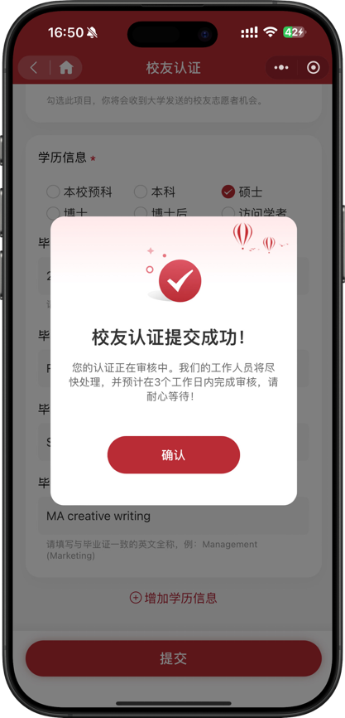

- How to organise your own alumni event
如何发起自己的校友活动
Verified alumni can submit their own alumni events or gatherings through the mini-app. This can include local meet-ups, industry sharing sessions, sports activities, career talks, or other activities that help bring the Bristol alumni community together.
已完成认证的校友可以通过小程序发起自己的校友活动或聚会。活动形式可以包括本地校友聚会、行业分享、体育活动、职业交流，或其他有助于连接布大校友社群的活动。

Step 1: Go to the event section
第一步：进入活动板块
In the mini-app, go to the alumni events section and select the option to create or submit an event.
进入小程序后，前往校友活动板块，并选择创建或提交活动的选项。

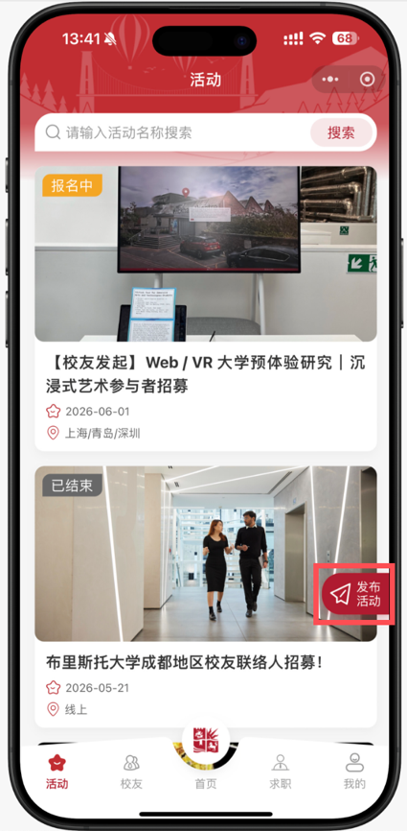
Step 2: Fill in the event information
第二步：填写活动信息
Please complete the event form with key details, such as the event title, date, time, city, venue, event description, capacity and any other information alumni may need to know before joining.
请填写活动相关信息，例如活动名称、日期、时间、城市、地点、活动介绍、人数限制，以及其他校友报名或参加活动前需要了解的信息。
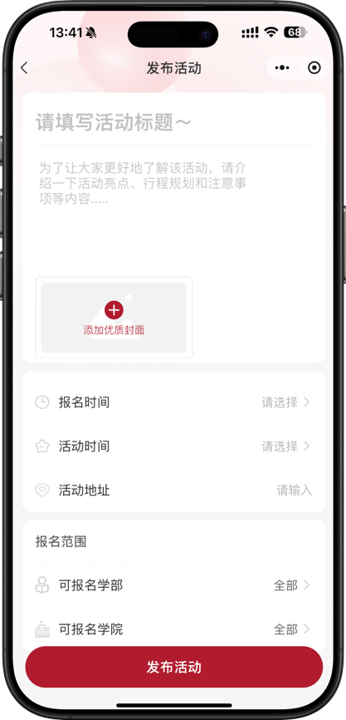
Step 3: Submit your event
第三步：提交活动
After completing the required information, please submit the event for review or publication through the mini-app.
完成所需信息填写后，请通过小程序提交活动，等待审核或发布。

Step 4: Manage your event
第四步：管理你的活动
Once your event is published, you can check the event details and manage registrations through the mini-app.
活动发布后，你可以在小程序中查看活动详情，并管理报名信息。

- How to post job opportunities
如何发布职业发展机会
Verified alumni can also post suitable job opportunities or career-related information through the mini-app to share with the wider Bristol alumni community.
已完成认证的校友也可以通过小程序发布合适的招聘信息或职业发展相关内容，与更广泛的布大校友社群分享。

Step 1: Go to the career section
第一步：进入职业发展板块
In the mini-app, go to the career section and select the option to post a new opportunity.
进入小程序后，前往职业发展或招聘信息板块，并选择发布新机会的选项。

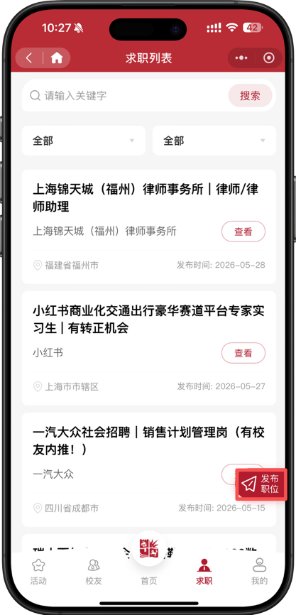

Step 2: Fill in the opportunity details
第二步：填写机会信息
Please complete the form with relevant details, such as the company or organisation name, position title, location, job description, requirements, application method and deadline.
请填写相关信息，例如公司或机构名称、职位名称、工作地点、职位介绍、申请要求、申请方式及截止日期等。

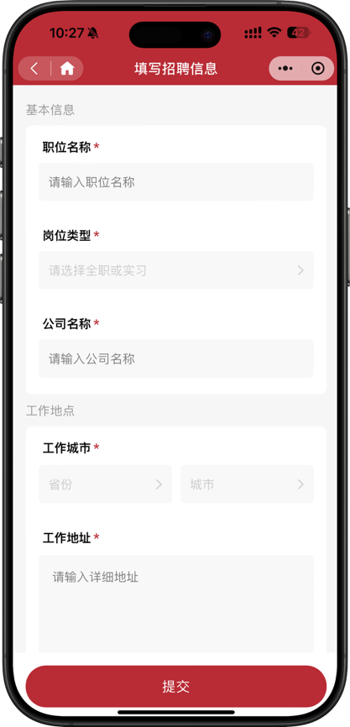

Step 3: Submit the opportunity
第三步：提交信息
After completing the required information, please submit the opportunity through the mini-app.
完成所需信息填写后，请通过小程序提交招聘或职业发展机会。

Step 4: Keep the information updated
第四步：及时更新信息
If the opportunity is no longer available, or if any details change, please update the information in the mini-app where possible.
如果该机会已经关闭，或相关信息发生变化，请尽可能及时在小程序中更新内容。

- Contact us
联系我们
If you have any other questions including problems with verification, please feel free to contact us at: joanna.zhao@bristol.ac.uk.
如果你在使用过程中有任何疑问，包括校友认证有问题，请电邮至：joanna.zhao@bristol.ac.uk.

